**Lab 3: Android Popup Menu**

# **Introduction**

A list of things is presented in an anchored modal popup window by Android's Popup Menu feature. If there is a room, the popup menu will show below the view; if there isn't, it will appear above the view. When we touch outside of the popup, it will automatically close.

**Let’s get Started:**

In this Exercise we will be implementing a **Popup Menu** in the android application.

**Step 1**: open an **activity_main.xml** file from **\res\layout** path and write the code like as shown below.

**activity_main.xml**

*<?*xml version="1.0" encoding="utf-8"*?>*<LinearLayout  
 xmlns:android="http://schemas.android.com/apk/res/android"  
 xmlns:app="http://schemas.android.com/apk/res-auto"  
 xmlns:tools="http://schemas.android.com/tools"  
 android:layout_width="match_parent"  
 android:layout_height="match_parent"  
 tools:context=".MainActivity"  
 android:gravity="center"  
 tools:ignore="MissingClass">  
  
 <Button  
 android:id="@+id/clickBtn"  
 android:layout_width="wrap_content"  
 android:layout_height="wrap_content"  
 android:background="#F57C00"  
 android:text="Click for PopUp Menu"  
 android:textColor="#ffffff"  
 app:layout_constraintBottom_toBottomOf="parent"  
 app:layout_constraintLeft_toLeftOf="parent"  
 app:layout_constraintRight_toRightOf="parent"  
 app:layout_constraintTop_toTopOf="parent" />  
</LinearLayout>

**Step2:**

In android, to define the **popup menu**, we need to create a new folder **menu** inside of our project resource directory (**res/menu/**) and add a new XML (**popup_menu.xml**) file to build the menu.

Now open newly created xml (**popup_menu.xml**) file and write the code like as shown below.

**popup_menu.xml**

*<?*xml version="1.0" encoding="utf-8"*?>*<menu xmlns:android="http://schemas.android.com/apk/res/android">  
 <item  
 android:id="@+id/java"  
 android:title="Android" />  
 <item  
 android:id="@+id/kotlin"  
 android:title="IoS" />  
 <item  
 android:id="@+id/android"  
 android:title="Windows" />  
 <item  
 android:id="@+id/react_native"  
 android:title="Blackberry" />  
</menu>

**Step2:**

Open main [activity](https://www.tutlane.com/tutorial/android/android-activity-lifecycle) file MainActivity.kt  and write the code like as shown below.

**MainActivity.kt**

**package** com.example.demopluralsightpopupmenu  
**import** android.os.Bundle  
**import** android.support.v7.app.AppCompatActivity  
**import** android.widget.Button  
**import** android.widget.PopupMenu  
**import** android.widget.Toast  
  
  
**class** MainActivity : AppCompatActivity() {  
 **lateinit var button**: Button  
  
 **override fun** onCreate(savedInstanceState: Bundle?) {  
 **super**.onCreate(savedInstanceState)  
 setContentView(R.layout.*activity_main*)  
 **button** = findViewById(R.id.*clickBtn*)  
 **button**.setOnClickListener **{  
 val** popupMenu = PopupMenu(**this**@MainActivity, **button**)  
 popupMenu.*menuInflater*.inflate(R.menu.*popup_menu*, popupMenu.*menu*)  
 popupMenu.setOnMenuItemClickListener **{** menuItem **->** Toast.makeText(**this**@MainActivity, **"Hey! You have Clicked "** + menuItem.*title*, Toast.*LENGTH_SHORT*).show()  
 **true  
 }** popupMenu.show()  
 **}** }  
}

**Step 3: Check Output on Android Emulator and it should look like as given below.**

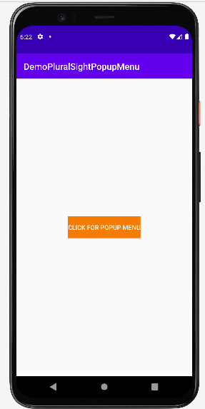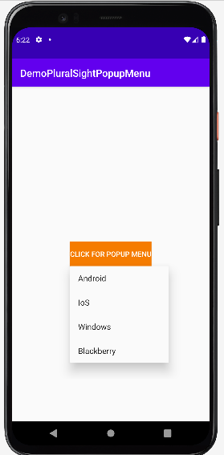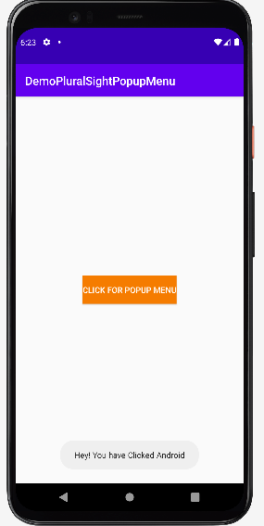

**Voila!!** We have successfully completed this lab.